**Topics: Normal distribution, Functions of Random Variables**

1. The time required for servicing transmissions is normally distributed with *μ* = 45 minutes and *σ* = 8 minutes. The service manager plans to have work begin on the transmission of a customer’s car 10 minutes after the car is dropped off and the customer is told that the car will be ready within 1 hour from drop-off. What is the probability that the service manager cannot meet his commitment?
2. 0.3875
3. 0.2676
4. 0.5
5. 0.6987

ANS: **B. 0.2676 26% is the probability that the service manager cannot meet his commitment**

*μ* = 45min, *σ* = 8min

*μ* =10min after = 45+10=55

Car will be ready in 1hr=60min(x)

Z=x- *μ*/*σ*

=60-55/8

=0.625

1-stats.norm.cdf(z)

1-stats.norm.cdf(0.625)

=0.2659

P value for z score is 0.2659 approx to 0.2676

1. The current age (in years) of 400 clerical employees at an insurance claims processing center is normally distributed with mean *μ* = 38 and Standard deviation *σ* =6. For each statement below, please specify True/False. If false, briefly explain why.
2. More employees at the processing center are older than 44 than between 38 and 44.

ANS:

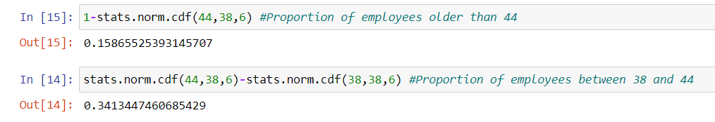

**Since the proportion of employees between 38 and 44 (0.3413) is greater than the proportion of employees older than 44 (0.1587), the statement is False.**

1. A training program for employees under the age of 30 at the center would be expected to attract about 36 employees.

ANS:

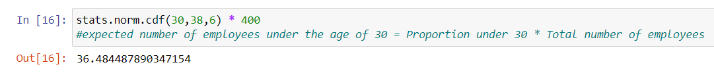

**It is TRUE statement.**

1. If *X1* ~ *N* (μ, σ2) and *X*2 ~ *N* (μ, σ2) are *iid* normal random variables, then what is the difference between 2 *X*1 and *X*1 + *X*2? Discuss both their distributions and parameters.

ANS:

Distribution of 2X1:

The mean of 2X1 can be calculated as: E(2X1) = 2E(X1) = 2μ

The variance of 2X1 can be calculated as: Var(2X1) = (2^2) * Var(X1) = 4σ^2

Distribution of X1 + X2:

The mean of X1 + X2 can be calculated as: E (X1 + X2) = E(X1) + E(X2) = μ + μ = 2μ

The variance of X1 + X2 can be calculated as: Var (X1 + X2) = Var(X1) + Var(X2) = σ^2 + σ^2 = 2σ^2

In conclusion, the difference between 2X1 and X1 + X2 lies in their variances. **The variance of 2X1 is 4 times larger than the variance of X1 + X2, while their means remain the same.**

1. Let X ~ N (100, 202). Find two values, *a* and *b*, symmetric about the mean, such that the probability of the random variable taking a value between them is 0.99.
2. 90.5, 105.9
3. 80.2, 119.8
4. 22, 78
5. 48.5, 151.5
6. 90.1, 109.9

ANS**: C. 48.5, 151.5**

P(a < x < b) = 0.99, µ=100, σ = 20

To Find:

Identify symmetric values for the standard normal distribution such that the

area enclosed is 0.99

Using Python

stats. norm.interval(0.99, 100, 20)

Two values symmetric about mean for the given standard normal distribution

are [48.5,151.5]

1. Consider a company that has two different divisions. The annual profits from the two divisions are independent and have distributions Profit1 ~ N(5, 32) and Profit2 ~ N(7, 42) respectively. Both the profits are in $ Million. Answer the following questions about the total profit of the company in Rupees. Assume that $1 = Rs. 45
2. Specify a Rupee range (centered on the mean) such that it contains 95% probability for the annual profit of the company.

ANS: 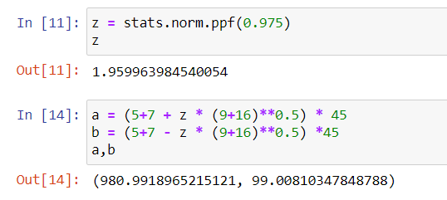 **Therefore, the Rupee range (centered on the mean) that contains 95% probability for the annual profit of the company is approximately Rs. 99.01 million to Rs. 980.99 million.**

1. Specify the 5th percentile of profit (in Rupees) for the company

ANS: 

1. Which of the two divisions has a larger probability of making a loss in a given year?

ANS: 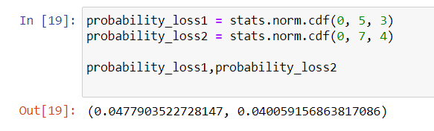

**Profit1 has a larger probability of making a loss in a given year compared to Profit2.**